Name:_____________________________ Class:_________ **Rocks and Minerals Unit**

M

**Handout 1: Layers of the Earth**

**Do Now:** Identify two items in your life that have layers: ___________________ __________________

**The Four-Layer Model of Earth:** *As you go deeper inside the Earth, pressure, heat and temperature all increase!*

|  |  |  |
| --- | --- | --- |
| **Crust** | * Where we live! * Very _________ in comparison to the other three layers.  1. Continental Crust -under _______ (continents) 2. Oceanic Crust - under the oceans  * The crust of the Earth is broken into many pieces called _________. |  |
| **Mantle** | * The mantle is the _____________ layer of the Earth. * The mantle is made of hot, dense, liquid _________ called ***magma*.** |
|  |
| **Outer Core** | * ____________ layer surrounding solid inner core * Composed of Iron and __________ * Convection (____________ of the liquid metal) in the Outer Core creates the *Earth’s magnetic field* |
| **Inner Core** | * A _________ metal ball * Made of an iron-nickel alloy |

**Turn and Talk:** *Which layer of the Earth would have the highest pressure?* _________________

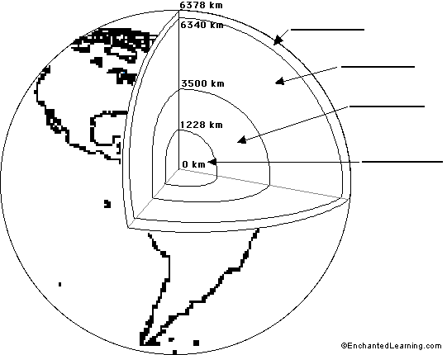

Label the diagram to the left.

**Word Bank:**

Mantle

Inner Core

Outer Core

Crust

|  |
| --- |
| **Directions: Use the words in the bank to fill in the blanks in the reading. Use each word only once.**    **Word Bank:** Temperature Mantle Crust Outer Core Magma Solid Pressure Liquid Metal  There are four layers in the Earth. The __________________ is the top layer. It is made out of ______________rock. This is where we live and the where the oceans are. It is very thin. The next layer is much thicker and called the _______________________. It is made out of melted rock, also called __________________, that is moving at all times. The next layer of the Earth is called the ______________. It is made out of very dense, super hot, melted _____________. It is so hot that it is no longer solid but _________________. The very center of the Earth is called the Inner Core. Both _______________ and _________________ increase the deeper you through the Earth: the crust is the coolest and the core is under high temperatures and pressure. |

*In the space below, write a poem, story, rap, or comic strip about a journey to the center of the Earth.*

**Use the following terms: *Crust, mantle, outer core and inner core***